**Software Requirements Specification (SRS)**

For projects

**1533 (CORAL VER2)**

Version: 1.0

|  |
| --- |
| **RESTRICTION OF USE, DUPLICATION, OR**  **DISCLOSURE OF PROPRIETARY INFORMATION**  This document contains proprietary information that is the sole property of DSIT. The document is submitted to the recipient for his use only. By receiving this document, the recipient undertakes not to duplicate the document or to disclose in part, or in whole any of the information contained herein to any third party without receiving beforehand written permission from DSIT. |

**Table of Contents**

1 Changes 3

2 *Project 1533*: 4

2.1 Introduction: 4

2.2 System block diagram 4

2.3 Objective 5

2.4 Errors indications and system failures treatment 5

2.5 Synthesizer registers values 6

3 Hardware 8

3.1 MCU Schematic 8

3.2 Microcontroller 9

3.3 GPIO and Analog Pin Assignments 9

4 Appendix A – How to set the registers values of sensitizer ADF-4351 10

# Changes

|  |  |  |  |
| --- | --- | --- | --- |
| Name | Change | Version | Date |
| Roee Zinoue | First Edition. | 1.0 | 18/01/18 |

# 

# Project 1533:

## Introduction:

This document describes the SW operation of the CORAL VER2 unit.

The system will consist two RF channels:

Transmit channel: will output RF signal with unique pattern that generated by the on board CPLD unit.

Receive channel: Will receive RF signal, if the signal match by his pattern to what expected the CPLD unit will indicate it to the on board MCU (which in final blink a connected LED to indicate about it).

Via serial connection we will able to control state of the transmitting / receiving and transmitting pattern. The system also have connect to MCU LEDs to indicate about the state of the system.

## System block diagram



## Objective

Main object of the MCU is collection data and indicate the user system about the RF signals states.

Goals of the Tx channel:

1. To configure synthesizer unit (ADF4113) to output RF signal in parameters of:

* Frequency of output signal: the Tx RF signal work at two ranges:
* Low frequency: at range of: 5.75 – 5.85 GHz.
* High frequency: at range of: 5.15 – 5.25 GHz.

Both ranges have step size of: 1 MHz.

* Frequency of PLL signal: the PLL will receive signals at range of:
* Low frequency: 2.575 – 2.625 GHz.
* High frequency: 2.8625 - 2.9125 GHz.

Both are divided by factor of 2.

Both ranges have step size of: 0.5 MHz.

* Advance power.
* If the signal latched by the receiving unit.
* Return power.

1. Transfer Tx channel to stand-by mode (at this mode no transmission will occur).
2. Turn on and off the power sensor.

Goals of the Rx channel:

1. Transfer Rx channel to stand-by mode (at this mode the system will not listen to any income RF signals).
2. Change working frequency mode of the frequency RF signal.
3. Turn on and off the RSSI sensor.

The above operation modes set by serial communication channel (using user inputs commands that set by terminal application).

The on board MCU unit also will collect samples data from on board ADC unit, write them to internal flash and will output them to user via serial channel at user request.

## Errors indications and system failures treatment

The system have two connected LEDs that indicate about the following system states:

1. Green led:

This led indicate that certain system operation is set correctly. It indicate about:

1. If system is initialize ok and ready to operate – the led will be stable for 3 seconds.
2. If frequency is latched on the on board synthesizer – the led will blink 3 times (the MCU at this state will stop sending the configuration word to the on board synthesizer).
3. Red led:

This LED indicate that certain system have failure on one of the requested operation. It indicate about:

1. If system is not success in initialize state– the led will be stable till system reset.
2. If the on board MCU don’t success to latch the selected frequency, the MCU will try to configure and send the digital words more 2 times. If after 3 times the frequency still not latched the red led will blink 5 times.

## Synthesizer registers values

Note: Please check Appendix A on this document describe to learn about the way of frequency in the sensitizer unit.

The following registers configurations will be set on the on board synthesizer:

1. *Frequency: 1.95 GHz:*

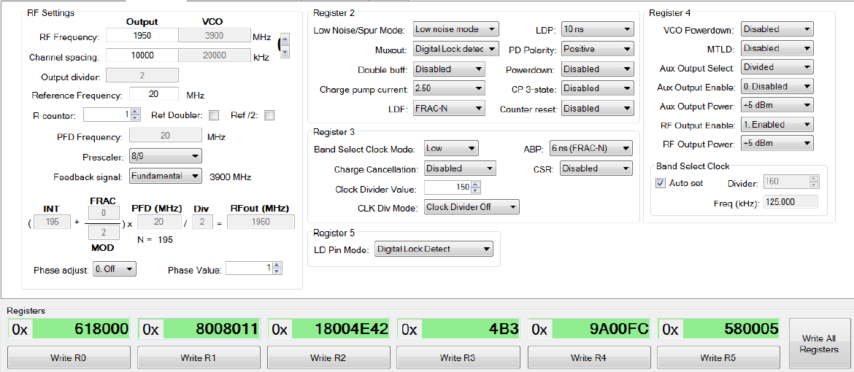

1. *Frequency: 2.8 GHz:*

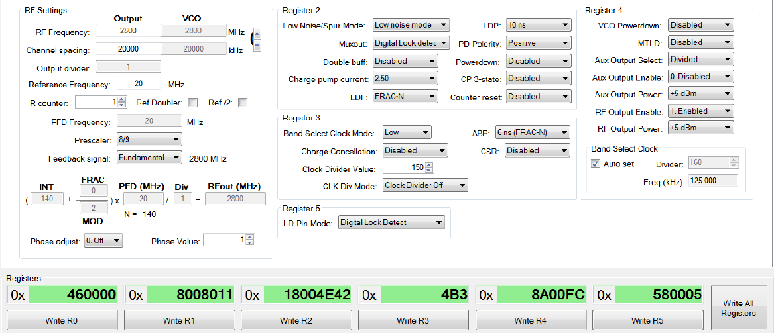

The configuration above taken from Analog devices ADF435x simulator.

# Hardware

## MCU Schematic



## Microcontroller

|  |  |
| --- | --- |
| **Recommended PIC** | **PIC16LF1823 – 8 bit core** |
| **Operating voltage** | **3.3V** |
| **Inputs (TTL / converter)** | **TBD** |
| **Outputs (TTL / converter)** | **TBD** |
| **POR** | **Available** |
| **Internal clock** | **8MHz and up to 32MHz** |
| **Pin count** | **14** |

* Flash Memory
  + The PIC microcontroller has 3.5KB (2K x 14) of internal flash memory. This memory will be used for store the internal synthesizer registers data.
* RAM Memory
  + The PIC microcontroller has 128 bytes of internal RAM, the system will use this memory for its software stack & heap.
* Peripherals support:
* Connectivity: 1-UART, 1-SPI, 1-I2C1-MSSP(SPI/I2C).
* ADC: 8 ch, 10-bit.

## GPIO and Analog Pin Assignments

|  |  |  |  |
| --- | --- | --- | --- |
| **Name in document** | **PIN Name** | **Net Name** | **Type** |
| **MCU power and programing pins** | | | |
| **3.3 VDC Enable** | **VDD** | **VDD** | **Input Analog** |
| **Digital ground** | **GND** | **GND** | **Input Analog** |
| **Program data Enable** | **RA0** | **PGDM** | **Bi-directional Discrete** |
| **Program clock Enable** | **RA1** | **PGCM** | **Input Discrete** |
| **System reset** | **RA3** | **MCLRM** | **Input Discrete** |
| **synthesizer** | | | |
| **SYNTH_CLK** | **RC0** | **SYNTH_CLK** | **Output Discrete** |
| **SYNTH_LE** | **RC5** | **SYNTH_LE** | **Output Discrete** |
| **SYNTH_LD** | **RA4** | **SYNTH_LD** | **Input Discrete** |
| **SYNTH_DATA** | **RC2** | **SYNTH_DATA** | **Output Discrete** |
| **System indication** | | | |
| **VCTRL_FHI** | **RC1** | **VCTRL_FHI** | **Output Discrete** |
| **VCTRL_FLO** | **RA5** | **VCTRL_FLO** | **Output Discrete** |
| **LED_ON1** | **RC3** | **LED_ON1** | **Output Discrete** |
| **LED_ON2** | **RC4** | **LED_ON2** | **Output Discrete** |
| **User selection** | | | |
| **FREQ_SEL** | **RA2** | **FREQ_SEL** | **Input Discrete** |

# Appendix A – How to set the registers values of sensitizer ADF-4351

** Please refer to unit datasheet for full details.

The Sensitizer ADF-4351 is software programmable unit which mean that each of the unit registers data is given and controlled by 4 registers that each one have control buffer of 32-bit. This registers configuration values will output from the on board MCU unit.

The synthesizer is also calibrated by the VCO (voltage controlled oscillator) and the frequency that comes after the VCO circuit can be calculated using the formula:

$$RF_{out}=f_{PDF}*(INT+ \frac{FRAC}{MOD})$$

When:

RFOUT: is the output frequency of the voltage controlled oscillator (VCO).

INT: is the preset divide ratio of the binary 16-bit counter.

FRAC: is the numerator of the fractional division (0 to MOD − 1).

MOD: is the preset fractional modulus (2 to 4095).

fPEF: is a frequency parameter that calculated from inputs parameters:

$$f_{PDF}=REF_{in}*\left[\frac{1+D}{R*\left(1+T\right)}\right]$$

When:

REFIN: is the reference input frequency.

D: is the REFIN doubler bit (0 or 1).

R: is the preset divide ratio of the binary 10-bit programmable reference counter (1 to 1023).

T: is the REFIN divide-by-2 bit (0 or 1).

**Example of frequency calculation:**

As an example, a UMTS system requires a 2112.6 MHz RF frequency output (RFOUT); a 10 MHz reference frequency input (REFIN) is available and a 200 kHz channel resolution (fRESOUT) is required on the RF output.

Note that the ADF4351 VCO operates in the frequency range of 2.2 GHz to 4.4 GHz. Therefore, the RF divider of 2 should be used (VCO frequency = 4225.2 MHz, RFOUT = VCO frequency/ RF divider = 4225.2 MHz/2 = 2112.6 MHz).

It is also important where the loop is closed. In this example, the loop is closed before the output divider (see Figure 30). fPFD PFD VCO N DIVIDER ÷2 RFOUT 09800-027 Figure 30.

Loop Closed before output Divider Channel resolution (fRESOUT) of 200 kHz is required at the output of the RF divider.

Therefore, the channel resolution at the output of the VCO (fRES) needs to be

2 × fRESOUT,

that is, 400 kHz. MOD = REFIN/fRES MOD = 10 MHz/400 kHz = 25 From Equation 4, fPFD = [10 MHz × (1 + 0)/1] = 10 MHz (5) 2112.6 MHz = 10 MHz × [(INT + (FRAC/25))/2] (6) where: INT = 422. FRAC = 13.